Unit 2

35
Semester 2 2018
Mathematics Methods Test 1

Total Time: | 30 minutes
Weighting: | 6% of the year.
This test comprises of TWO sections. The first section is calculator free where no calculators of any kind are to be used. The second section is calculator assumed where the CAS calculator may be used. All questions must be answered in both sections. Answers should be in EXACT form or rounded appropriately. All working should be shown in the space provided. Solutions without working may not be awarded full marks. Please take the marks for each question into account when answering the question.
SECTION 1: CALCULATOR FREE
Time: 30 minutes |  |  | Equipment Allowed: SCSA Formula sheets
Marks for Section 1: 26 marks

Australind Test 4
QUESTION 1 (1,2,3,3 = 9 marks)

Simplify each of the following leaving answers with positive indices:

- a³b³ x a⁻²b⁻⁷

QUESTION 2 (2,2 = 4 marks)

Simplify:

- (

Carine SHS Test 4
QUESTION 3 (2, 2, 2 = 6 marks)

(a) Simplify the following, leaving all indices positive.

(i) 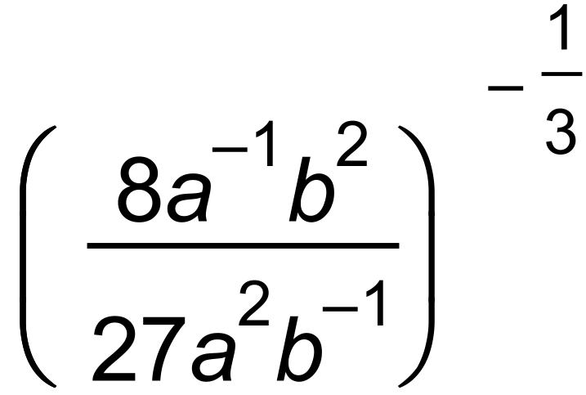

(ii) 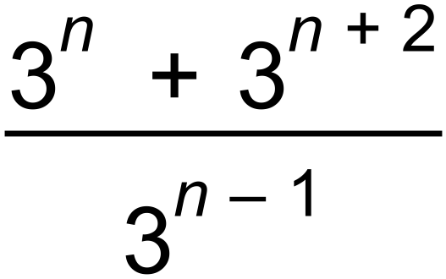

(b) Solve for x.
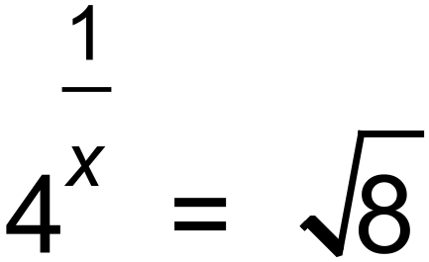

QUESTION 4 (2 marks)
Determine the value of $n$ in the following:
$\frac{a^{9}÷a^{n}}{a^{3}×a^{2}}$ $=a^{3}$

Carine SHS Test 5
QUESTION 5 [2,2,2 = 6 marks]

Solve for x in each case showing working clearly.

- 4^{x-3} = b)

c)

QUESTION 5 (3, 1 = 4 Marks)

(a) Determine the equation of the function shown on the set of axes below.

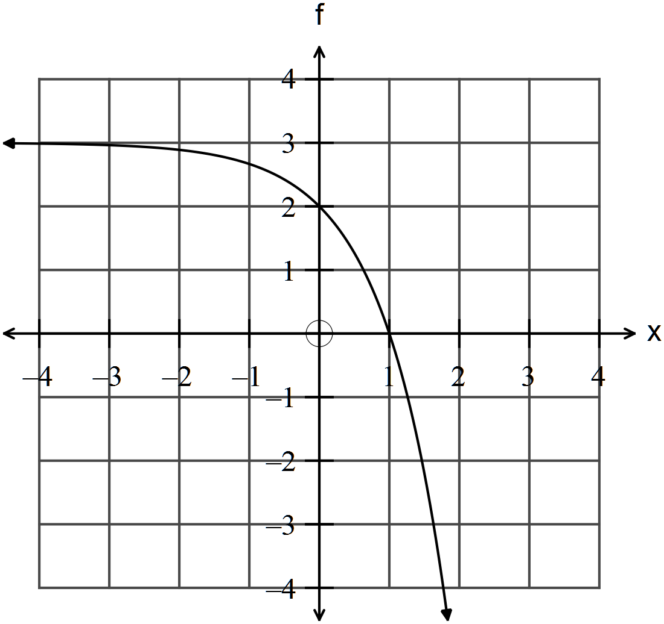

(b) An exponential function is $f\left(x\right)=4^{x-5}+2$

Give the equations of any asymptotes.

************

SECTION 2: Calculator Assumed

QUESTION 6 (1, 1, 2 = 4 marks)

The number of bacteria in a culture doubles every 5 days.
After $x$ days, the number of bacteria $N$ is given by $N=790×2^{0.2x}$

- Find the initial number of bacteria.

- Determine the number of bacteria after 3 weeks.

